**Are prognostic type 2 diabetes risk prediction algorithms racially biased?**

Héléne Toinét Cronjé, PhD1, Alexandros Katsiferis, MSc1, Leonie K. Elsenburg, PhD1, Thea O. Andersen, MSc1, Tri-Long Nguyen, PhD1, Naja H. Rod, PhD1, Tibor V. Varga, PhD1,*

**Affiliations:**

1. Section of Epidemiology, Department of Public Health, University of Copenhagen, Copenhagen, Denmark

* Corresponding author:

Tibor V. Varga

ORCID: <https://orcid.org/0000-0002-2383-699X>

Postal address:

Bartholinsgade 6Q

DK-1356 Copenhagen K

Denmark

Tel: +45 35 32 77 39

E-mail: tibor.varga@sund.ku.dk

Abstract word count: max 300, currently 296

Manuscript word count: max 3500, currently 3425

# Abstract

**Background**: The deployment of prognostic risk prediction models for type 2 diabetes (T2D) can be useful for the early detection of high-risk individuals, contributing to healthcare programs aiming to rapidly intervene and thereby reduce T2D risk. However, prognostic models also have the ability to bias clinical decision-making processes, for instance by differential risk prediction across racial groups. The aims of the current study were to investigate whether landmark prognostic models of T2D demonstrate racial biases in T2D prediction, and recommend concrete action points to promote fair disease prediction.

**Methods**: We analyzed data (1999-2010) from the National Health and Nutrition Examination Survey (NHANES) sampled in six independent two-year batches. A total of 14,638 adults without a prior diagnosis of T2D with fasting blood samples available were included in our analysis. Multiple imputation was applied to the six survey batches for the purpose of calculating race- and year-specific average predicted incidences for T2D according to three, landmark prognostic algorithms. Summary calibration of the models was performed by comparing the calculated race-stratified T2D average predicted incidences with observed incidences extracted from the US Diabetes Surveillance System.

**Findings**: All investigated landmark T2D prognostic models were found to be miscalibrated with regards to race. The Framingham Offspring Risk Score overestimated T2D risk for non-Hispanic Whites and underestimated risk for non-Hispanic Blacks and Hispanics. The rest of the models overestimated risk for all ethnicities. The expected-to-observed incidence ratios did not manifest significant inconsistencies across the survey years, and appeared to benefit non-Hispanic Whites by potentially prioritizing larger fractions from this group for preventive interventions compared to minority groups.

**Interpretation**: Our findings indicate that landmark T2D models have the potential to perpetuate inequalities in clinical decision making. We recommend that future prognostic models implemented in healthcare should be required to demonstrate algorithmic fairness.

**Funding**: University of Copenhagen, Novo Nordisk Foundation

# Research in context

**Evidence before this study**

The recent years revealed that various healthcare processes, that have the ability to impact the health of populations, are wrought with algorithmic bias, disproportionately impacting minorities, for instance by identifying at-risk individuals at a different stage in their disease progression across racial groups. From the numerous prognostic prediction models for type 2 diabetes aiming to identify at-risk individuals for preventive action, none are currently adopted by US healthcare.

**Added value of this study**

Using data from the National Health and Nutrition Examination Survey, we provide evidence that prognostic type 2 diabetes prediction models currently likely candidates for adoption in healthcare in the US are also likely to be biased, in identifying proportionately less at-risk individuals from minorities compared to the non-Hispanic Whites. These findings are consistent over time, and also applicable for models that were designed in cohorts including multiple ethnic groups.

**Implications of all the available evidence**

Combined evidence from previous studies and this report indicate that algorithmic bias in clinical care is a prevalent and yet unaddressed problem. In light of the accumulated evidence, here we provide concrete recommendations for key stakeholders in the development and adoption of healthcare algorithms to ensure equitable clinical decision making. Namely, we outline various considerations for investigators with the aim of developing fair predictive models, recommend that specific fairness reporting criteria be adopted by journals publishing predictive models, and that clinical and academic expert groups consider fairness as a key criteria in adopting novel algorithms in healthcare.

# Introduction

Type 2 diabetes (T2D) affects one in eight adults in the United States (US), and it is the nation’s seventh leading cause of death1,2. T2D carries a plethora of adverse health consequences as well as high costs for both the individual and the society1. According to the Center of Disease Control, T2D is the most expensive chronic condition in the US3. A look beyond the averages shows a disparity in the toll of diabetes across racial groups. The population average of one in eight translates to one in six among non-Hispanic Blacks, one in seven among Hispanics and non-Hispanic Asians, and one in nine among non-Hispanic Whites. Similarly, among racial minorities in the US, diabetes ranks higher on the list of leading causes of death2. While socioeconomic status has been strongly associated with risk of T2D4, the observed risk differences between racial groups are not fully understood5,6. While T2D carries a huge cost, it should be acknowledged that health inequalities in itself also carry tremendous direct and indirect costs7,8. Thus, reducing healthcare processes that perpetuate inequalities will not only improve individual human lives, but entire economies.

Early detection of individuals who are at high risk for developing the T2D emerged as a powerful strategy to tackle the diabetes epidemic, as it allows early and targeted intervention and prevention. Ample evidence supports the efficacy of implementing diabetes prevention programs worldwide9. Notably, using prognostic risk prediction models, the United Kingdom’s ‘Healthier You: National Health Services Diabetes Prevention Programme’ has identified thousands of individuals at high risk of developing T2D, which enabled early intervention and the reduction of T2D risk of these individuals via structured support from healthcare, adoption of healthier lifestyles, and reductions in adiposity and glycemia10.

Several prognostic models have been developed for predicting T2D, many of them in the US11. Despite the success of prognostic models forecasting cardiovascular diseases12, somewhat surprisingly, none of the T2D models gained traction in US primary care, even though their performance can be considered satisfactory 12. Instead, the American Diabetes Association recommends the use of a diagnostic risk score that was developed to identify individuals with already present, latent T2D or prediabetes13. However, we do expect the implementation of prognostic T2D prediction models in US, as well as other countries, in the near future, as prevention of T2D and its comorbidities (e.g. obesity, and cardiovascular diseases) and complications will be cheaper on the long run than the treatment of them3. Furthermore, the wide implementation and success of prognostic predictive models for cardiovascular diseases already paved the way for how such models can be widely utilized to prevent disease and improve health14.

The current US Standard of Medical Care in Diabetes incorporates various aspects of race-based risk stratification for T2D15. These include alternative body mass index cut-off points for the classification of overweight individuals across racial groups, and non-White race as a criterion for higher frequency screening. In line with these considerations, some predictive models for T2D also include race as a predictive variable, a feature that has been at the center of academic and ethical debate16-21. Despite the fact that non-White race is related to increased diabetes risk22, most published models for the prediction of T2D were developed and validated in predominantly non-Hispanic White cohorts11. This racial homogeneity may hold important implications for the performance of prediction models across racial groups, namely, most models are expected to underperform for minorities.

Systemic inequalities in disease prediction are expected to exacerbate health disparities, for instance via prioritizing individuals of certain racial groups for preventive action at different rates, or at different stages in their disease progression23. Thus, when implementing predictive models in primary care, we must make sure that models are equitable. In this project we set out to investigate whether landmark prognostic prediction models of T2D, that would currently be candidates for adoption in USA primary care, demonstrate racial biases in T2D prediction. In addition, we will recommend concrete action points for stakeholders to promote fair prognostic disease prediction.

# Materials and Methods

**Study population**

The National Health and Nutrition Examination Survey (NHANES) is a repeated cross-sectional survey that provides a vast amount of publicly available health data on a nationally representative sample of the civilian, non-institutionalized US population in two-year intervals, since 199924. Reliability of sub-group data is ensured by the oversampling of minority racial groups and persons over the age of 60. Data collected include demographic, questionnaire, biochemical and physical examination. A detailed description of the NHANES is available elsewhere24.

For the analyses presented in this paper we included NHANES survey content between 1999 and 2010, sampled in six independent 2-yrs batches (1999-2000, 2001-2002, …, 2009-2010). A total of 62,160 participants were surveyed during this timeframe, of whom 22,661 provided fasted blood samples. Analyses were restricted to fasted participants due to the utilization of fasting biochemical measures in the prediction algorithms tested, and thus, the fasting subsample weights were used to correct for representativeness in all analyses. Individuals with prior or prevalent T2D (based on self-report and medication use), and those younger than 18 years (n=8,023) were excluded; thus the final total sample used for our analysis consisted of 14,638 individuals. The sample selection and analytic strategy is shown on Figure 1. The NHANES was subject to ethics review by the National Center for Health Statistics Research Ethics Review Board and approval was obtained bi-annually between each full proposal review. All participants provided informed consent.

**Prediction models**

A recently published systematic review11 was used to identify T2D risk prediction models developed in North America (n=5). The enhanced Atherosclerosis Risk in Communities (ARIC) model and the Diabetes Population Risk Tool (DPoRT) were excluded due to unavailable features in NHANES, and an ambiguous model definition, respectively. Thus, the Framingham Offspring Risk Score25, the ARIC Risk Model26, and the San Antonio Risk Model27 were included in our analyses (**Supplemental Table 1**).

**Predictors in NHANES**

Continuous predictors included in the three models were age (years), BMI (kg/m2), waist circumference (cm), height (cm), systolic and diastolic blood pressure (mmHg), fasting glucose (mmol/L), high-density lipoprotein cholesterol (mmol/L) and triglycerides (mmol/L). Race was used as a categorical predictor (Hispanic [Mexican American and other Hispanic], non-Hispanic Black, non-Hispanic White, Other). Binary predictors were sex (male/female), family history of diabetes (yes/no; yes when participants answered in the affirmative to any of the specific family members questioned explicitly in 1999-2004, and from 2005 when participants answered yes to the single question of whether a close relative has diabetes), and anti-hypertensive medication use (yes/no).

**Statistical analysis**

All analyses were undertaken using R 4.1.2. Our core analysis began by calculating predicted incidences for each individual according to the three utilized models. We subsequently calculated race- and year-specific average predicted incidences (and 95% confidence intervals [CIs]) for each survey batch.

This analysis was undertaken in the framework depicted in Figure 1: The data of 14,638 individuals in six survey batches were imputed using multivariate imputation by chained equations28. For all variables, random forest was utilized (number of iterations = 5), and as suggested by White *et al*. based on the average missingness in the original data (15.2%), 15 imputed copies were generated29. The imputation models included the sampling weights to account for the complex survey design30. Convergence was visually inspected for randomly selected imputed datasets. Race- and survey-specific estimates from the multiple imputation framework were pooled using Rubin’s rules. Cumulative incidences (matched to the respective risk score time frames) were calculated as the sum of yearly reported incidences extracted from the US Diabetes Surveillance System database31, and were subsequently compared with the NHANES-derived weighted average predicted incidences.

**Role of the funding source**

The funders had no role in study design; in the collection, analysis, and interpretation of data; in the writing of the report; and in the decision to submit the paper for publication.

# Results

Weighted, unimputed descriptive statistics of the study population are presented per survey year in **Table 1**. Imputed descriptive statistics per survey year are shown in **Supplemental Table 2**.

Race-stratified age-adjusted T2D incidence rates extracted from the US Diabetes Surveillance System are presented in **Supplemental Table 3**31. T2D incidence peaked in 2008, and has been decreasing since. There was considerable variation across racial groups, with both non-Hispanic Blacks and Hispanics consistently having higher incidence rates compared to non-Hispanic Whites.

Predicted average incidences for each examined T2D model were compared with cumulative incidences calculated from the US Diabetes Surveillance System. As an example, we used the NHANES cohort from 1999 to calculate race-stratified 8-yrs average predicted T2D incidences, and thus, calculated that by 2007, 7% of non-Hispanic Whites, 6% of non-Hispanic Blacks, 7% of Hispanics, and 7% of the overall population is expected to develop T2D. We compared our calculated estimates with real-life race-stratified cumulative incidences from the matching 8-yrs period (2000-2007) (cumulative incidences for this period are 5% for non-Hispanic Whites, 8% for non-Hispanic Blacks, 8% for Hispanics, and 6% for the overall population). We repeated this analysis for each model, and each of the six cohorts from NHANES between 1999-2010, to obtain race-stratified predicted estimates until 2017 (Supplemental Table 4). Results for the three T2D prediction models are shown in Figures 2, 3 & 4 (panel A).

While the Framingham Offspring Risk Score overestimates T2D risk for non-Hispanic Whites, it underestimates risk for non-Hispanic Blacks and Hispanics. The other two models overestimate T2D risk for all races. We further observed our findings by calculating the ratios of the calculated average predicted incidences to the real-life cumulative incidences Figures 2, 3 & 4 (panel B). All five models demonstrate the largest overestimation of risk for non-Hispanic Whites. The ARIC model has the lowest overestimation for non-Hispanic Blacks (average ratio = 1.22 vs. 2.31 for White), while the San Antonio model has the lowest overestimation for Hispanics (average ratio = 1.87 vs. 3.45 for Whites).

# Discussion

In recent decades, algorithmic decision making has become a routine part of healthcare; simple risk scores that are already widely utilized represent the status quo of evaluating an individual’s risk of developing a disease for most cardiometabolic outcomes, including T2D13, and complex artificial intelligence-driven models are used to predict common complications of T2D32. Regardless of the complexity of these algorithms, recent examples have shown that models developed based on biased datasets, or not directly addressing data biases, will likely propagate inequalities into clinical decisions that have the ability to impact human lives23,33. As a result of biased algorithmic decision making, those who were already marginalized and less represented, may encounter further obstacles in access to optimal healthcare, generating a vicious cycle. In this report, we investigated whether three landmark T2D predictive models developed in the US were racially biased. We compared the proportion of the population identified as being at high risk for incident T2D with corresponding reported national statistics on T2D incidence by racial group, within the predicted time horizon.

We interpret the model-derived proportions, indicating the population at risk for incident T2D within a certain timeframe, as the fraction of the racial groups that would be prioritized for preventive intervention in that timeframe. When models underestimate the proportion of the population at risk for incident T2D compared with national statistics on incident T2D, this indicates that the models identify less individuals in need for preventive action than the actual needs based on national statistics. Conversely, in case of overestimation, larger fractions of the population would be prioritized for preventive action and larger numbers would potentially receive support to achieve their health targets than it would be necessary based on national statistics. Imbalances in over- and underestimation between racial groups reflect algorithmic bias, i.e. systematic differences in the performance of algorithms across specific groups. Overdiagnosis and overtreatment pose significant challenges, such as the detection and unnecessary treatment of individuals who will ultimately remain asymptomatic34. However, in the case of T2D, the current consensus on preventive action largely involves non-invasive lifestyle interventions, which are less likely to pose harm to false positives compared to e.g. pharmaceutical treatment.

Our results show that all three tested T2D risk prediction models (Framingham Offspring Risk Score, ARIC model, and the San Antonio model) consistently demonstrate the largest risk overestimation for non-Hispanic Whites. The two models developed in racially mixed cohorts with the intent to tailor prognosis to specific racial groups (ARIC and San Antonio models) demonstrate the lowest overestimation of TD2 risk for minorities. The Framingham Offspring Risk Score, developed in a 99% White and non-Hispanic population, underestimates risk for minorities. These findings cautiously indicate that, proportionally, non-Hispanic Blacks and Hispanics would be neglected for diabetes prevention interventions compared to their non-Hispanic White counterparts, if these models were to be implemented in primary care today. As such, implementation of these models could have the potential to perpetuate and reinforce inequalities.

A potential reason for the algorithmic bias that we observe is the underrepresentation of minorities in studies where models were developed. When it comes to sample size considerations in developing novel algorithms, three major approaches are to be considered. The first approach is to develop models in nationally representative populations. This will result in predictive models that will perform more accurately for the majority. This approach was taken when developing the ARIC Model26 that was developed in a cohort that consisted of 15% non-Hispanic Blacks. For this model, we see marked differences in the performance between non-Hispanic Whites and Blacks. The second approach is to develop models in cohorts with roughly equal sample sizes across groups, resulting in models that are expected to perform with the same confidence and precision across groups. The third approach is to develop separate models in separate groups. This approach was taken when developing the Reynolds Risk Scores predicting 10-yrs cardiovascular disease risk, which was done separately for women35 and men36. While both total sample size and sample size of respective groups are important considerations in the development of prediction models, societal and data biases will also impact the development and subsequent performance of algorithms. For instance, while the San Antonio Model was developed in a cohort with >50% Hispanics27, our results remain indicative of algorithmic bias continuing to disadvantage Hispanics; despite accounting for Hispanic race in risk prediction, the model was not sufficient to capture individuals at the same rate as it does for non-Hispanic Whites.

Prediction models can perpetuate and reinforce data biases that lie in the core of the societies we live in. Explicit counteraction is warranted to address these biases when developing prediction models. In recent years, algorithmic fairness, as an emergent research area, received increasing attention and the development of toolkits for the development of fair models took flight37. It has been raised that without the consideration of sensitive attributes (e.g. race, or other variables depending on the context such as ethnicity, sex, gender, age, presence of disabilities, etc.), it is cumbersome to correct for data biases, and thus, develop fair models38. However, the inclusion of race as a feature in predictive models has been at the center of academic debate16,18,21. For instance, the vast majority of clinical prediction models for cardiovascular diseases do not include race in the assessment of individual risk18. Arguments for the omission of these sensitive attributes are that racial discrimination can potentially be reinforced with the addition of race in the models (i.e. racial profiling), and that there is only weak evidence for genetic or biological differences across races19. Additionally, researchers have expressed concern that race insertion might create risks of falsely interpreting racial inequities as immutable facts rather than disparities that require intervention17,20.

Nonetheless, variables encoding race are deemed to reflect a complex combination of factors related to biological, cultural, as well as socio-contextual aspects. Therefore, while the use of race as a predictor may suffer from crucial flaws, it can also pave the way for better algorithmic decision making across various racial groups - for example, by promoting personalized care, targeting those at most need for intervention, at the right time18. The exclusion of race from algorithms may lead to differential external validity and potentially harmful decision making, as models may fail to account for differential risk across groups19. Undeniably, we are currently facing a ‘data problem’: data currently used to generate novel models are likely to embed inherent racist structures, lack intersectionality and/or important social-contextual features that potentially confound the association between race and various clinical endpoints20,21. Thus, it is crucial for future studies to investigate complex diseases through a ‘structural racism lens’39,40 and disentangle causal relationships between various socioeconomic factors, human physiology, and outcomes, in pursuit of identifying the most appropriate candidate features for predictive modeling.

We recommend that any published and/or candidate diagnostic or prognostic models be required to demonstrate algorithmic fairness before adoption in healthcare, e.g. via a systematic comparison of their performance in external samples stratified by sensitive attributes, such as race, ethnicity, and sex. Until fairness is a default consideration in algorithmic development, and models adopted by healthcare are thoroughly checked for fairness, it is likely that societal inequalities will propagate into clinical decisions. Thus, we call for medical journals to recommend reporting criteria related to the fairness of novel predictive algorithms. While numerous toolkits, checklists and governance frameworks have been developed on the topic41, we emphasize five key points that journals may want to require reporting on: (i) potential data biases; (ii) possible measurements of bias; (iii) utilized bias mitigation strategies; (iv) potential impacts of the biases; (v) and the generalizability of results across relevant sensitive attributes. We recommend that expert groups and healthcare policy makers responsible for the adoption of any risk models (e.g. cutoffs, simple risk scores, or complex algorithms) in clinical practice consider fairness a decisive factor.

Our study needs to be considered under some limitations. First, the predictive performance of the models could not be assessed in terms of discrimination and calibration as in their traditional reported form. The repeated cross-sectional design of the NHANES did not allow us to compare the individual predicted probabilities returned by the prediction models with the individual observed outcomes, since participants were not followed-up over time. However, we were able to compare the average predicted T2D incidences and compare these estimates with the average incidences that were observed, which led us to estimate a summary measure of calibration. Using this overall calibration measure (ratio of expected to observed), we could show disparities in terms of over- and underestimation of the incidence of T2D across racial groups. Second, we caution against an interpretation of the trend over time in the estimated predictive performance, as it is impossible to know if changes in observed incidence over time were merely due to changes in case detection or not. If the case detection was skewed in different directions across racial groups (i.e. differential measurement error), then the disparities we showed in terms of over- and underestimation could be either exaggerated or attenuated. Yet, current national data of diagnosed/undiagnosed T2D indicate no remarkable differential detection42. Third, the complex survey design of NHANES complicated the estimation procedure in the presence of missing item responses. To address this issue, we performed multiple imputation, while including the sampling weights in the imputation models30, and using random forest models to allow for complex interactions and non-linearities to be captured43. Fourth, the three models that we examined in this report were developed in older populations compared to the NHANES samples that we used in this analysis. We believe that this would result in lower fidelity predictions for individuals, but would not impact our main results which are solely based on average predicted incidences by racial groups. Last, we acknowledge that a large number of T2D models are available and it would be possible to extend our list. Here we selected widely known models developed in the US, but future reports could possibly include a wider range of models for testing.

In conclusion, our study shows that prognostic T2D prediction models currently available for adoption in healthcare are likely wrought with algorithmic bias, which in turn is likely to maintain the status quo by providing less benefits to minorities, who already demonstrate higher risk for metabolic diseases. We provide specific recommendations that we believe can improve the standards of publishing, and the adoption of algorithmic processes in healthcare.

# Acknowledgements

**Author contributions**

Authors' contributions: The corresponding authors attest that all listed authors meet the ICMJE authorship criteria and that no others meeting the criteria have been omitted. TVV is the guarantor of this manuscript. All listed authors reviewed and edited the manuscript, verified the data, and approved the final, submitted version.

**Declaration of interests**

The authors declare no conflict of interest.

**Data availability statement**

NHANES data is publicly available and can be accessed via https://www.cdc.gov/nchs/nhanes/index.htm

**Funding**

HTC is supported by a grant from Novo Nordisk Foundation Challenge Programme for the project Harnessing the Power of Big Data to Address the Societal Challenge of Aging (NNF17OC0027812).

# References

1. Control CfD, Prevention. National diabetes statistics report, 2020. *Atlanta, GA: Centers for Disease Control and Prevention, US Department of Health and Human Services* 2020: 12-5.

2. Heron M. Deaths: Leading Causes for 2019. *Natl Vital Stat Rep* 2021; **70**(9): 1-114.

3. (NCCDPHP) NCfCDPaHP. Cost-Effectiveness of Diabetes Interventions. [ <https://www.cdc.gov/chronicdisease/programs-impact/pop/diabetes.htm> ]. Accessed: 26 Jan 2022. 2021.

4. Agardh E, Allebeck P, Hallqvist J, Moradi T, Sidorchuk A. Type 2 diabetes incidence and socio-economic position: a systematic review and meta-analysis. *International journal of epidemiology* 2011; **40**(3): 804-18.

5. Nair ATN, Donnelly LA, Dawed AY, et al. The impact of phenotype, ethnicity and genotype on progression of type 2 diabetes mellitus. *Endocrinology, Diabetes & Metabolism* 2020; **3**(2).

6. Golden SH, Yajnik C, Phatak S, Hanson RL, Knowler WC. Racial/ethnic differences in the burden of type 2 diabetes over the life course: a focus on the USA and India. *Diabetologia* 2019; **62**(10): 1751-60.

7. LaVeist TA, Gaskin DJ, Richard P. The economic burden of health inequalities in the United States. 2009.

8. Mackenbach JP, Meerding WJ, Kunst AE. Economic costs of health inequalities in the European Union. *Journal of Epidemiology & Community Health* 2011; **65**(5): 412-9.

9. Dunkley AJ, Bodicoat DH, Greaves CJ, et al. Diabetes prevention in the real world: effectiveness of pragmatic lifestyle interventions for the prevention of type 2 diabetes and of the impact of adherence to guideline recommendations: a systematic review and meta-analysis. *Diabetes care* 2014; **37**(4): 922-33.

10. Valabhji J, Barron E, Bradley D, et al. Early outcomes from the English National health service diabetes prevention programme. *Diabetes care* 2020; **43**(1): 152-60.

11. Ayensa-Vazquez JA, Leiva A, Tauler P, et al. Agreement between Type 2 Diabetes Risk Scales in a Caucasian Population: A Systematic Review and Report. *Journal of clinical medicine* 2020; **9**(5): 1546.

12. Noble D, Mathur R, Dent T, Meads C, Greenhalgh T. Risk models and scores for type 2 diabetes: systematic review. *Bmj* 2011; **343**: d7163.

13. Association AD. <https://www.diabetes.org/risk-test>.

14. McElduff P, Lyratzopoulos G, Edwards R, Heller R, Shekelle P, Roland M. Will changes in primary care improve health outcomes? Modelling the impact of financial incentives introduced to improve quality of care in the UK. *BMJ Quality & Safety* 2004; **13**(3): 191-7.

15. Committee ADAPP, Committee: ADAPP. 2. Classification and Diagnosis of Diabetes: Standards of Medical Care in Diabetes—2022. *Diabetes care* 2022; **45**(Supplement_1): S17-S38.

16. Essien UR, Jackson LR. Race effects in CVD prediction models. *Journal of general internal medicine* 2019; **34**(4): 484-.

17. Lett E, Asabor E, Beltrán S, Cannon AM, Arah OA. Conceptualizing, Contextualizing, and Operationalizing Race in Quantitative Health Sciences Research. *Annals of family medicine*: 2792.

18. Paulus JK, Kent DM. Race and ethnicity: a part of the equation for personalized clinical decision making? *Circulation: Cardiovascular Quality and Outcomes* 2017; **10**(7): e003823.

19. Paulus JK, Wessler BS, Lundquist CM, Kent DM. Effects of race are rarely included in clinical prediction models for cardiovascular disease. *Journal of general internal medicine* 2018; **33**(9): 1429-30.

20. Vyas DA, Eisenstein LG, Jones DS. Hidden in plain sight—reconsidering the use of race correction in clinical algorithms. Mass Medical Soc; 2020. p. 874-82.

21. Waters EA, Colditz GA, Davis KL. Essentialism and Exclusion: Racism in Cancer Risk Prediction Models. *JNCI: Journal of the National Cancer Institute* 2021.

22. Wang MC, Shah NS, Carnethon MR, O’Brien MJ, Khan SS. Age at diagnosis of diabetes by race and ethnicity in the United States from 2011 to 2018. *JAMA internal medicine* 2021; **181**(11): 1537-9.

23. Obermeyer Z, Powers B, Vogeli C, Mullainathan S. Dissecting racial bias in an algorithm used to manage the health of populations. *Science* 2019; **366**(6464): 447-53.

24. Statistics. CfDCaPNCfH. National Health and Nutrition Examination Survey. [ <https://www.cdc.gov/nchs/nhanes/index.htm> ]. Accessed: 26 Jan 2022.

25. Wilson PW, Meigs JB, Sullivan L, Fox CS, Nathan DM, D’Agostino RB. Prediction of incident diabetes mellitus in middle-aged adults: the Framingham Offspring Study. *Archives of internal medicine* 2007; **167**(10): 1068-74.

26. Schmidt MI, Duncan BB, Bang H, et al. Identifying individuals at high risk for diabetes: The Atherosclerosis Risk in Communities study. *Diabetes care* 2005; **28**(8): 2013-8.

27. Stern MP, Williams K, Haffner SM. Identification of persons at high risk for type 2 diabetes mellitus: do we need the oral glucose tolerance test? *Annals of internal medicine* 2002; **136**(8): 575-81.

28. Van Buuren S, Groothuis-Oudshoorn K. mice: Multivariate imputation by chained equations in R. *Journal of statistical software* 2011; **45**: 1-67.

29. White IR, Royston P, Wood AM. Multiple imputation using chained equations: issues and guidance for practice. *Statistics in medicine* 2011; **30**(4): 377-99.

30. Kim JK, Michael Brick J, Fuller WA, Kalton G. On the bias of the multiple‐imputation variance estimator in survey sampling. *Journal of the Royal Statistical Society: Series B (Statistical Methodology)* 2006; **68**(3): 509-21.

31. US Diabetes Surveillance System. [ <https://gis.cdc.gov/grasp/diabetes/DiabetesAtlas.html#> ]. Accessed: 26 Jan 2022.

32. Gulshan V, Peng L, Coram M, et al. Development and Validation of a Deep Learning Algorithm for Detection of Diabetic Retinopathy in Retinal Fundus Photographs. *JAMA : the journal of the American Medical Association* 2016; **316**(22): 2402-10.

33. Sjoding MW, Dickson RP, Iwashyna TJ, Gay SE, Valley TS. Racial bias in pulse oximetry measurement. *New England Journal of Medicine* 2020; **383**(25): 2477-8.

34. Vogt H, Green S, Ekstrøm CT, Brodersen J. How precision medicine and screening with big data could increase overdiagnosis. *Bmj* 2019; **366**.

35. Ridker PM, Buring JE, Rifai N, Cook NR. Development and validation of improved algorithms for the assessment of global cardiovascular risk in women: the Reynolds Risk Score. *JAMA : the journal of the American Medical Association* 2007; **297**(6): 611-9.

36. Ridker PM, Paynter NP, Rifai N, Gaziano JM, Cook NR. C-reactive protein and parental history improve global cardiovascular risk prediction: the Reynolds Risk Score for men. *Circulation* 2008; **118**(22): 2243-51.

37. Bellamy RK, Dey K, Hind M, et al. AI Fairness 360: An extensible toolkit for detecting and mitigating algorithmic bias. *IBM Journal of Research and Development* 2019; **63**(4/5): 4: 1-4: 15.

38. Zliobaite I. Fairness-aware machine learning: a perspective. *arXiv preprint arXiv:170800754* 2017.

39. Adkins-Jackson PB, Chantarat T, Bailey ZD, Ponce NA. Measuring structural racism: a guide for epidemiologists and other health researchers. *American journal of epidemiology* 2021.

40. Robinson WR, Renson A, Naimi AI. Teaching yourself about structural racism will improve your machine learning. *Biostatistics* 2020; **21**(2): 339-44.

41. Madaio MA, Stark L, Wortman Vaughan J, Wallach H. Co-designing checklists to understand organizational challenges and opportunities around fairness in ai. Proceedings of the 2020 CHI Conference on Human Factors in Computing Systems; 2020; 2020. p. 1-14.

42. Prevention CfDCa. Prevalence of Both Diagnosed and Undiagnosed Diabetes. [ <https://www.cdc.gov/diabetes/data/statistics-report/diagnosed-undiagnosed-diabetes.html> ]. Accessed: 26 Jan 2022.

43. Shah AD, Bartlett JW, Carpenter J, Nicholas O, Hemingway H. Comparison of random forest and parametric imputation models for imputing missing data using MICE: a CALIBER study. *American journal of epidemiology* 2014; **179**(6): 764-74.

# Tables

**Table 1.**

|  |  |  |  |  |  |  |  |
| --- | --- | --- | --- | --- | --- | --- | --- |
| **Table 1. Unimputed descriptive statistics of the NHANES data (N=14,638).** | | | | | | | |
|  | **1999–2000** | **2001–2002** | **2003–2004** | **2005–2006** | **2007–2008** | **2009–2010** |
| **N** | 2,243 | 2,544 | 2,295 | 2,320 | 2,531 | 2,705 |
| **Age**, years | 43.2 (16.8) | 43.4 (18.8) | 43.8 (17.0) | 44.4 (17.2) | 44.4 (17.0) | 44.7 (17.1) |
| **Female**, % | 52.0 | 52.0 | 52.1 | 51.4 | 51.3 | 51.9 |
| **Ethnicity**, % |  |  |  |  |  |  |
| Non-Hispanic Black | 10.2 | 10.7 | 11.0 | 11.0 | 10.6 | 11.0 |
| Hispanic | 14.6 | 12.1 | 11.0 | 11.4 | 13.7 | 13.8 |
| Non-Hispanic White | 71.1 | 72.5 | 72.6 | 72.1 | 70.0 | 68.5 |
| Other | 4.1 | 4.7 | 5.5 | 5.5 | 5.7 | 6.7 |
| **Family history of diabetes**, % | 44.1 | 46.5 | 46.1 | 36.6 | 33.1 | 32.0 |
| Missing | 5.4 | 5.7 | 6.9 | 6.9 | 6.0 | 5.4 |
| **Height**, cm  Missing | 169.2 (10.0)  1.0 | 169.2 (10.1)  2.8 | 169.9 (9.9)  1.4 | 169.4 (10.1)  1.5 | 169.6 (10.2)  1.7 | 169.2 (9.9)  0.7 |
| **Body mass index**, kg/m2  Missing | 27.3 (5.9)  1.0 | 27.7 (6.2)  5.5 | 28.0 (6.2)  1.5 | 28.3 (6.9)  1.6 | 27.8 (6.0)  1.7 | 28.4 (6.6)  0.9 |
| **Waist circumference**, cm  Missing | 93.6 (15.5)  2.4 | 94.8 (15.2)  5.0 | 96.4 (15.4)  4.7 | 96.7 (16.4)  4.4 | 95.8 (15.1)  5.6 | 97.1 (15.9)  4.2 |
| **Fasting glucose**, mmol/L  Missing | 5.1 (1.1)  6.6 | 5.1 (1.1)  6.6 | 5.2 (0.8)  5.5 | 5.2 (1.0)  6.4 | 5.1 (0.8)  6.2 | 5.2 (1.0)  5.4 |
| **Hypertension**, % | 39.8 | 42.0 | 39.0 | 37.3 | 35.3 | 35.3 |
| **Systolic BP**, mmHg | 121.3 (17.7) | 121.9 (18.6) | 121.2 (18.2) | 120.9 (17.0) | 119.1 (16.0) | 118.2 (15.7) |
| **Diastolic BP**, mmHg  Missing | 72.2 (11.9)  3.1 | 72.3 (11.9)  4.6 | 70.4 (12.7)  5.6 | 68.6 (12.5)  4.9 | 69.3 (11.8)  5.1 | 68.2 (11.9)  5.0 |
| **BP medication use**, % | 13.4 | 15.4 | 16.5 | 17.0 | 19.0 | 19.2 |
| Missing | 83.9 | 82.0 | 81.2 | 79.3 | 78.4 | 78.6 |
| **HDL-C**, mmol/L  Missing | 1.3 (0.4)  6.7 | 1.3 (0.4)  6.9 | 1.4 (0.4)  5.2 | 1.4 (0.4)  6.1 | 1.4 (0.4)  6.1 | 1.4 (0.4)  5.1 |
| **Triglycerides**, ln(mmol/L)  Missing | 0.3 (0.5)  6.9 | 0.3 (0.6)  6.9 | 0.3 (0.6)  5.4 | 0.2 (0.6)  6.5 | 0.2 (0.6)  6.2 | 0.2 (0.5)  5.2 |
| Data displayed as means (standard deviations).  Abbreviations: HDL-C: high-density lipoprotein cholesterol, BP: blood pressure.  NHANES fasting survey weights were used to estimate weighted means and variances. | | | | | | | |

# Figures

**Figure 1. Study flowchart.**

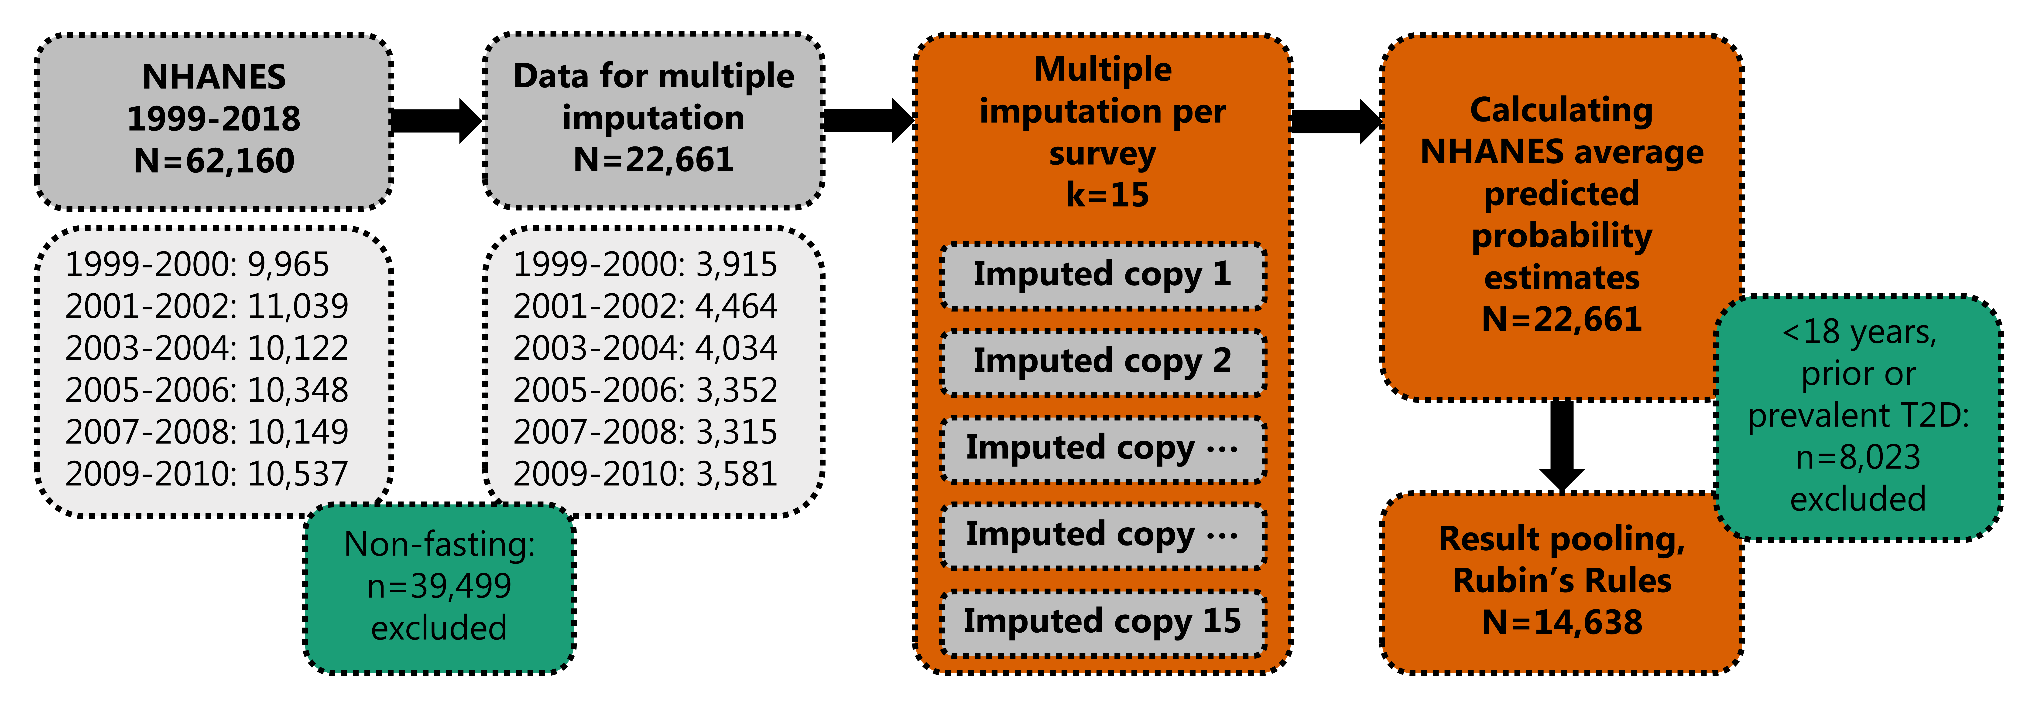

**Figure 2. A) Average predicted incidences of developing T2D per racial group by the Framingham Offspring Risk Score and 8-yr cumulative incidences of T2D from the U.S. Diabetes Surveillance System. B) Ratios between average predicted incidences and cumulative incidences of T2D from the U.S. Diabetes Surveillance System per racial group by survey year.**

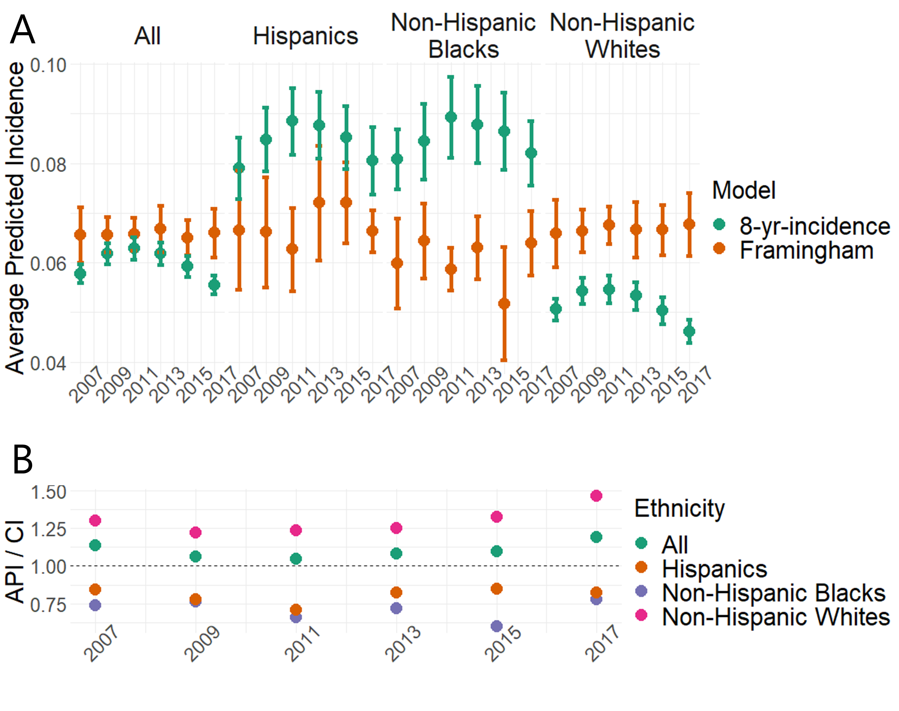

Abbreviations: API - average predicted incidence; CI - cumulative incidence.

Error bars reflect 95% confidence intervals.

**Figure 3. Average predicted incidences of developing T2D per racial group by the ARIC Model and 9-yr cumulative incidences of T2D from the U.S. Diabetes Surveillance System. B) Ratios between average predicted incidences and cumulative incidences of T2D from the U.S. Diabetes Surveillance System per racial group by survey year.**

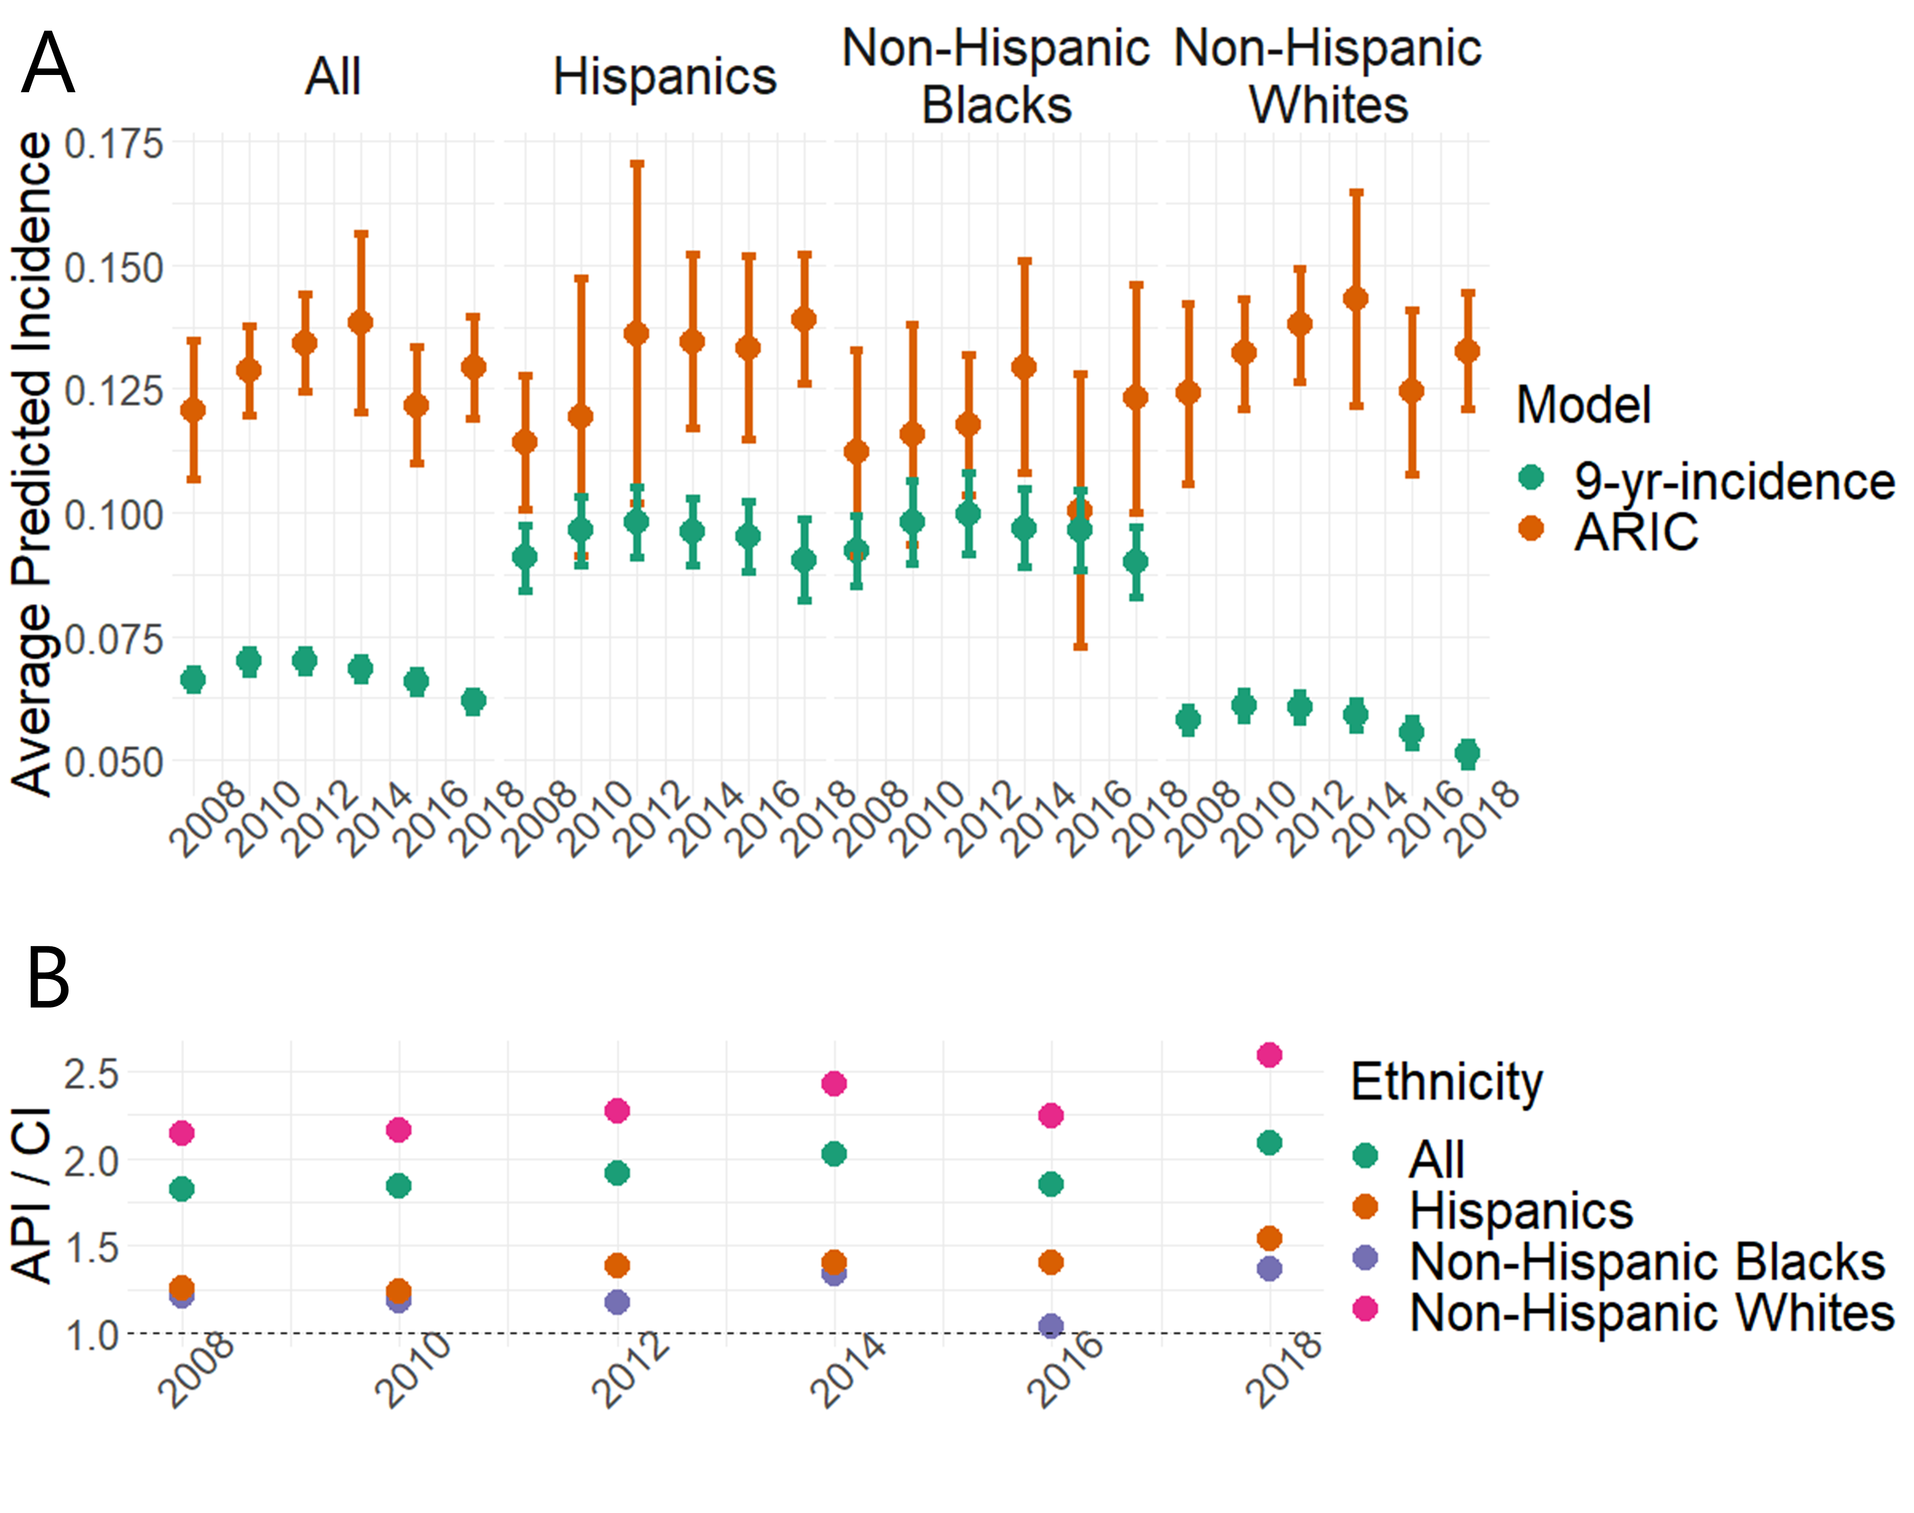

Abbreviations: API - average predicted incidence; CI - cumulative incidence.

Error bars reflect 95% confidence intervals.

**Figure 4. Average predicted incidences of developing T2D per racial group by the San Antonio Model and 8-yr cumulative incidences of T2D from the U.S. Diabetes Surveillance System. B) Ratios between average predicted incidences and cumulative incidences of T2D from the U.S. Diabetes Surveillance System per racial group by survey year.**

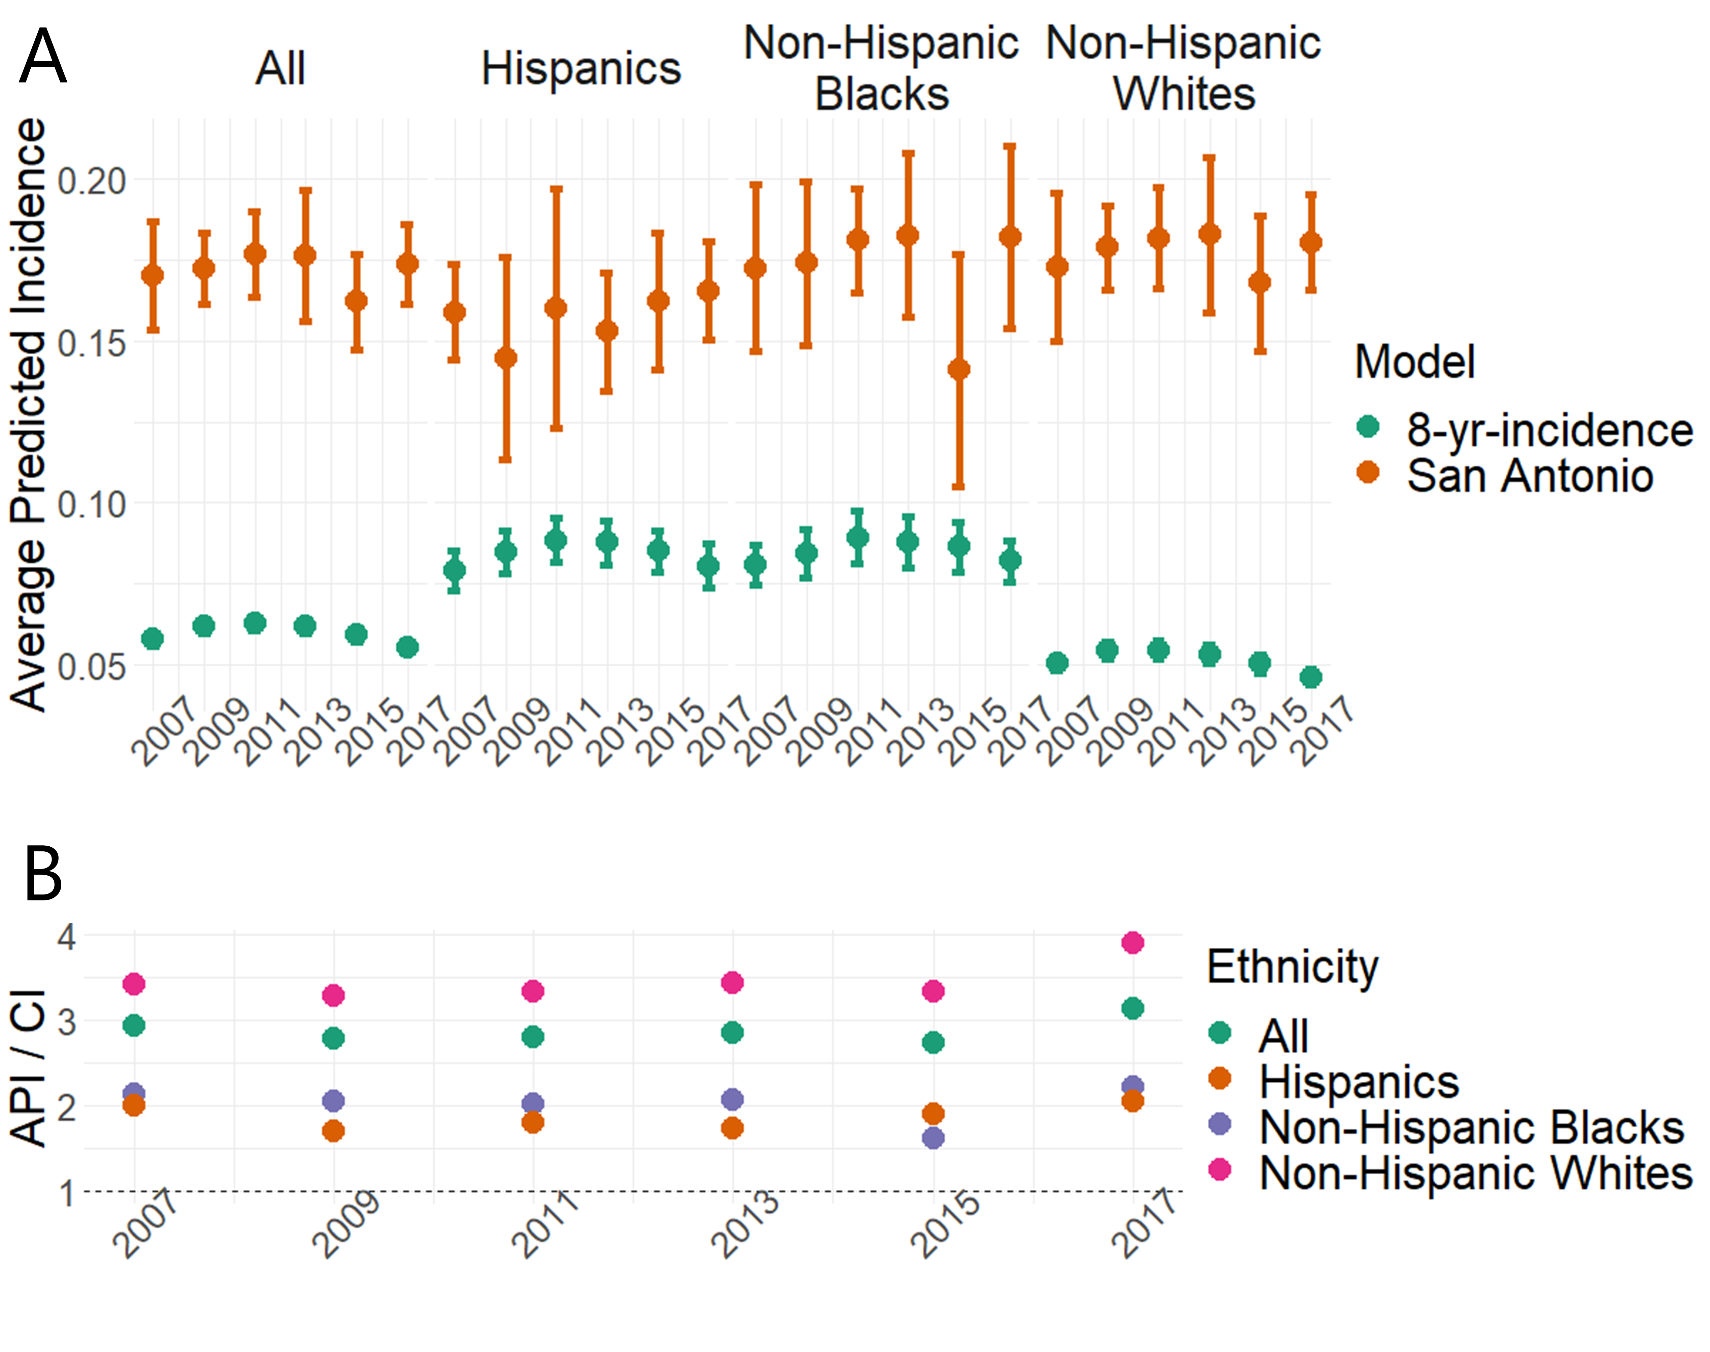

Abbreviations: API - average predicted incidence; CI - cumulative incidence.

Error bars reflect 95% confidence intervals.

# Supplemental material headings

**Supplemental Table 1.** Type 2 diabetes risk prediction model included in the analytic framework.

**Supplemental Table 2.** Descriptive statistics of the imputed NHANES data.

**Supplemental Table 3.** Age-adjusted incidence rates of type 2 diabetes per 1000 individuals.

**Supplemental Table 4.** Average predicted incidences of developing type 2 diabetes per racial group by the three risk prediction models and cumulative incidences of type 2 diabetes from the U.S. Diabetes Surveillance System.